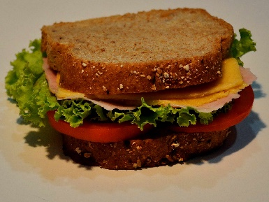
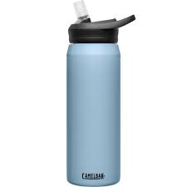

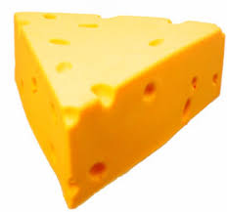
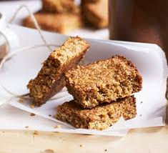
Use tin foil, beeswax wraps or Tupperware instead of cling film to wrap sandwiches.
Bring a reusable water bottle or reuse a plastic one instead of throwing it away.
Written by the Eco School Committee
We hope these tips help you to save the environment!
Buy a big packet of things like cheese and yoghurt and put into smaller pieces in Tupperware to cut down on packaging.
Make home-made snacks to cut down on plastic wrappers.
Eco School
Tips for Plastic-Free Packed Lunches

